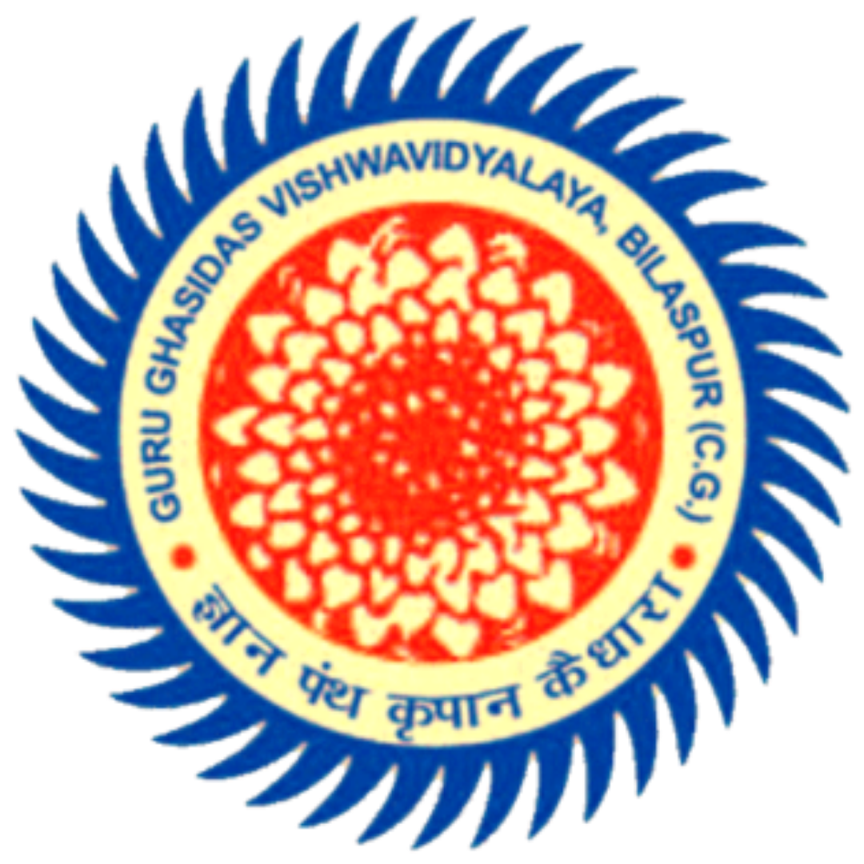

| **Malla Raraju**  **B.Tech in Computer Science and Engineering**  **School of Studies in Engineering and Technology,**  **Guru Ghasidas Vishwavidyalaya, Bilaspur**  *A Central University established by the Central University Act 2009 No. 25 of 2009* | *+91 6266080778*  [*raraju2001@gmail.com*](mailto:raraju2001@gmail.com) |
| --- | --- |

| **Degree** | **University /Institute** | **Year** | **CPI / %** |
| --- | --- | --- | --- |
| B.tech | Institute of Technology, Guru Ghasidas Vishwavidyalay, Bilaspur | 2023 | 7.79/10.00 |
| Intermediate | Narayana Junior College, Sheela Nagar, Visakhapatnam | 2018 | 91.9% |
| Matriculation | Sri Gouri Vidhyanikethan, Yelamanchili, Visakhapatnam | 2016 | 9.5/10.0 |

**EXPERIENCE**  _____________________________________________________________________

***Sponsorlytix*** | *Intern* | ***November 2022-December 2022***

* It’s a UK based Artificial Intelligence & Big Data Analytics company,which was a part of Dantani Sports Group. My role in the company is computer vision engineer.

***Personifwy |*** *trainee* ***| May 2022- August 2022***

* Personifwy is an AI - powered talent engagement and enablement platform.I did an industrial project assigned by the company. It’s a virtual work experience program conducted by the company.

**KEY PROJECTS**  __________________________________________________________________

***YOLO version 3 enhancement* | *Jan 2023 - Apr 2023***

* We did architectural changes in the YOLO v3 for better detection of the small scale objects.

***YouOnlyLookOnce-Ver3(Object Detection) | Python, Deep Learning, Google Collaboratory | April 2022***

* Analyzed the working process of YOLO version3.
* Implemented the Object Detection algorithm in Google Collab using python and shell script.

***Breast Cancer classification | Python, Deep Learning, Google Collaboratory | November 2021***

* Implemented a breast cancer classification algorithm using Python in Google Collaboratory to classify whether a provided mammography consists of stage1 or stage2 cancer.
* Implemented convolutional neural network to extract data from the images.

**ACHIEVEMENTS**  _________________________________________________________________

* Earned Gold Badge in Hacker rank for Python and 30 days of code.
* Earned 10 badges in my Google Developers profile.
* Certified as a Python developer and also for Problem solving by Hacker rank.

**TECHNICAL SKILLS**  ______________________________________________________________

* ***Languages:*** Python, Opencv, Computer Vision fundamentals, Octave(basics), Deep Learning, TensorFlow, Keras.
* ***Developer Tools:*** Eclipse, Android Studio, GNU octave, Command Prompt, Spyder, Jupyter notebook.
* ***Technologies/Frameworks:*** Google Collaboratory, GitHub, Dialog Flow.